Rosie Revere’s Orangutan Dilemma Worksheet
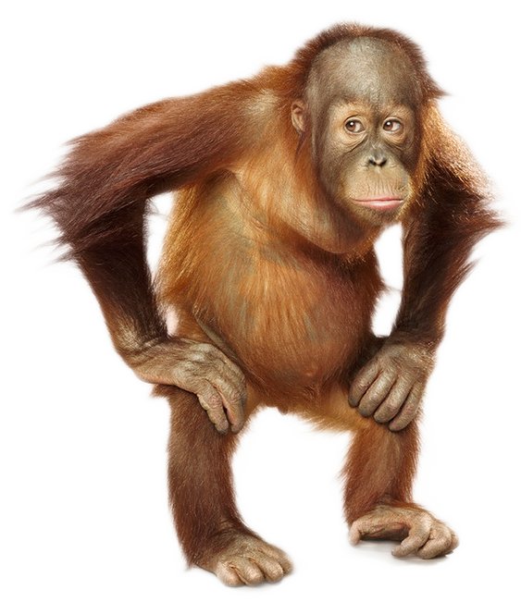
Design Challenge: Uncle Fred is having a problem keeping the orangutans in their zoo enclosures overnight. The orangutans have designed strategies to escape and cause all sorts of shenanigans with other animals. Uncle Fred needs you to help Rosie design a solution that will keep the orangutans from escaping their enclosure. The enclosure can only use the materials provided by your teacher, and must not harm the orangutans. The enclosure must also incorporate the Crumble components.

Vocabulary Terms: Engineering Design Process, electricity, circuit, sparkle, electronic sensor, switch, buzzer, coding, and prototype.

How could you use the Crumble to help Uncle Fred?
______________________________________________________________________________
______________________________________________________________________________
______________________________________________________________________________

Provide sketches of what the enclosure could look like:

What problems did you encounter while building and programing your design? How did you troubleshoot these issues?

______________________________________________________________________________
______________________________________________________________________________
______________________________________________________________________________
______________________________________________________________________________

