Investigation 1: What Did Prehistoric Connecticut Look Like?

(Engage Activity)

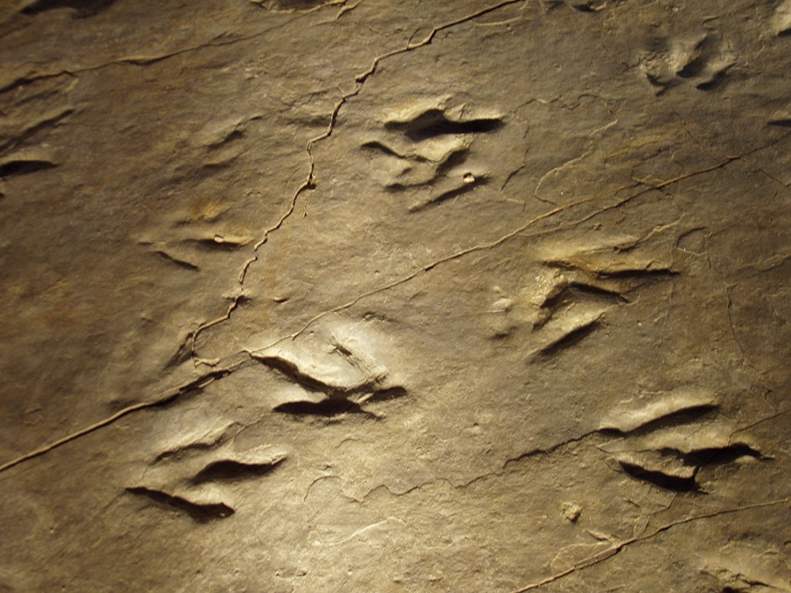
Introduction.
We know that dinosaurs roamed prehistoric Connecticut. In fact, we have 200 million-year-old world-renowned dinosaur footprint fossils from the Connecticut River Valley (see Figure 1).

Many of these fossils are located at Dinosaur State Park in Rocky Hill, CT. Today, we know dinosaurs no longer roam Connecticut’s temperate deciduous forests and pastures.

Figure 1: Eubrontes Dinosaur Footprints in CT

Describing Prehistoric Connecticut.
- To learn more about our fossils, read a short blog published by the Connecticut Science Center. As we read the article aloud, record your reactions to it in the space below.

- Now that we know a little about these dinosaurs, visualize what prehistoric Connecticut might have looked like when these dinosaurs roamed the earth. For instance: what was Connecticut’s climate and land look like? What kind of fauna and animals existed?
To respond to these questions, record your ideas in the left-hand column (I Think) of Table 1.1. Then, share your ideas with the group. As we share, record your classmates’ ideas that you believe are important to add to your ideas about what prehistoric CT was like in the right-hand column (We Think). HINT: Rereading the article may help you with this.
Table 1.1: I Think, We Think
I Think | We Think

- Next, read the short academic article titled Fossils of the Connecticut River Valley. This article, written by two Trinity College professors, is from a larger academic article titled Geology, Formation and Fossils of the Connecticut Valley (2006). This reading is about fossils from Connecticut that provide clues to what Connecticut’s prehistoric environment looked like.
TIP: There may be many new vocabulary words that you may not be familiar with. The words with the blue hyperlinks link to Wikipedia, which provides more details about the word.
Teaching Note: We have also provided you with a modified version of the text as an example of how you may have to modify text for some of your readers. You can use the website REWORDIFY.COM as a place to start.
As you read, mark, or annotate, the text using the text codes in Table 1.2 (below) to identify places in the text that help support or add to your initial ideas about what Connecticut used to look like.
Table 1.2: Text Coding
* (star) = this idea/concept supports my initial description
+ (plus sign) = this idea/concept adds to my initial description.
- (minus sign) = this idea/concept contradicts my initial description.
? (question mark) = this idea/concept I don’t understand or have a question about.
NOTE: You also may create your own text codes as you see fit.
- Next, add any new ideas you’d like to include about what prehistoric Connecticut looked like.

- Overall, describe how prehistoric Connecticut compares to what it looks like today?
Prehistoric Connecticut | Connecticut Today

Hypothesizing and Modeling What CT’s Prehistoric Environment Looked Like.
Today, Connecticut has a temperate environment—with cold winters and warm summers. We learned that when the dinosaurs roamed Connecticut, it had a tropical environment—a climate that is warm and humid year-round.
- Brainstorm probable factors that could explain why there is difference between our present-day temperate climate and the prehistoric tropical one? Record one or two plausible hypotheses.
Factors

Hypotheses

- Next, share your factors and hypotheses with your classmates. Record any new ideas in the space below.
- Now that you know what Connecticut’s climate and landscape may have been like 200 million years ago, we will figure out what caused this drastic change. Thus, work with your group to create a science model that shows the process (mechanism) that caused this change. Please focus on the main factor you selected previously (see #6). Use the “Gotta-Have-It Checklist” Table 1.3 to help construct your model.
Table 1.3: Gotta-have-it Checklist
- Title on top of model: What caused prehistoric Connecticut to change?
- The location of the phenomenon (CT).
- The landscape and climatic conditions, both observable and unobservable (e.g. temperature).
- Time passing—then and now (estimate timing if needed).
- The factors/mechanisms that is causing the change in CT’s landscape.
- Include labels (e.g. words & phrases) to identify parts of the model and arrows to identify relationships among the parts.
- Names of group member in pencil on the back
NOTE: This is a preliminary model. We will make changes to address alternate conceptions and omissions as we go through the unit.
- Post and share your model. Record how other models compare to your own. What did you learn from this experience? Record below.

Investigation 2: Wegener’s Prehistoric Fossils

(Explore Activity #1)

Introduction.
Thus far, we only have a preliminary explanation or hypothesis for why Connecticut had a tropical climate 200 million years ago. As such, our goal is to better understand how this phenomenon could occur considering Connecticut presently has a temperate climate—with all four seasons.
Recently, Alfred Wegener, a German-born meteorologist, has been collecting fossils mostly from Africa, South America, Australia, India, and Antarctica. Most of them are from the Triassic period (about 250-200 million years ago). One of his most recent fossil discoveries was from Antarctica. There, he found Glossopteris and Lystrosaurs fossils—both unusual discoveries. The Glossopeteris was a tropical fern. Alfred wondered how this plant could be fossilized on a continent covered primarily with ice. The Lystrosaurs was a land reptile that is not tolerant to this kind of cold climate. He also noted that these fossils were found on other landmasses such as South America and Africa. This was puzzlng to Alfred.
The Task.
From the above description of evidence, Dr. Wegener proposed a probable explanation/hypothesis:
Alfred Wegener’s Hypothesis:
Earth’s landmasses must have been located closer to the equator—near tropical environments—as well as closer to one another.
Wegener understands that his plausible explanation/hypothesis lacks support based on evidence he analyzed thus far. Since Dr. Wegener has much more fossil evidence that can potentially be used as additional support for his hypothesis, he is asking you to help him. Not only can this additional evidence be used to support his hypotheses, but this evidence may also be used to support your initial explanation too (from Investigation 1). Below are materials and guidelines Dr. Wegener has used to help him decipher and analyze this data.
Materials.
Triassic Fossil Field Notes | Google Maps | Colored Pencils
Fossil Evidence Map Record | Scissors | Glue
Analysis Guidelines.
- Explore Table 2.1: Triassic Fossil Field Notes. The first column lists the four fossils Wegener took field notes on. In the second, third, and fourth columns are the landmass, present-day country, and cities where these fossils are located. Important: You can click on the name of each fossil in the table to learn more about this prehistoric animal.
- Use the field notes and Google Maps to shade the areas where these fossils were located (using column 2 and 3) onto the “Conintental Puzzle Pieces in Figure 1.” Also, plot the cities (from column 4) on the map to show where these fossils were found too.
- Next, cut out the landmass shapes along the continental shelf (see Figure 2: Present-day World Map). Then, try to piece them together as one large landmass. Consider how the different shapes of the continents fit together by matching up the fossils that are shaded on them. This will be a process of trial and error until you feel comfortable that you solved the “puzzle.”
- Once you figure out the configuration, please paste/tape landmasses into Table 2.2.

Table 2.1: Triassic Fossil Field Notes
The first column below lists the four fossils you will plot onto the your “fossil evidence map record.” Click on the live link to learn more about each fossil. The color you will shade the areas on the map are also listed in the first column. The remaining three columns identified the present-day land mass, country, and some selected cities that these fossils are located.
Fossil &  Description | Present Day Location of Fossils
 | Landmass | Country | Cities
Glossopteris  A fern found in tropical regions  Color the areas with these fossils in green | South America | - Southern Uruguay  - North central Argentina | - Montevideo  - Buenos Aries, Rosario, Santa Fe, Mar del Plata
 | Africa | - Namibia  - Botswana  - Zambia  - Zimbabwe  - Southern Tanzania  - Northern Mozambique | - Windhoek, Walvis Bay  - Maun  - Lusaka  - Bulawayo, Harare  - Mtwara  - Nacala
 | India | - Southern India | - Mangalura, Madurai, Chennai
 | Antarctica | - See map—please color this on the “map record” | - n/a
 | Australia | - Southeast Australia | - Adelaide, Melbourne, Sydney
Cynognathus  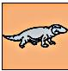  A land reptile  Color the areas with these fossils in orange | South America | - Southern Brazil  - Paraguay  - Bolivia | - Curitiba, Rio de Janeiro, Victoria  - Asuncion  - Cochabamba, Tarija
 | Africa | - Northern Angola  - Congo  - Northern Democratic Republic of the Congo | - Luanda  - Pointe-Noir  - Mbandaka, Bumba
Lystrosaurus  A land reptile  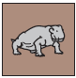  Color the areas with these fossils in brown | Africa | - Southern Kenya  - Northern Tanzania  - Rwanda  - Burundi  - Southeast Democratic Republic of the Congo | - Mombasa  - Dar es Salaam  - Butare  - Bujumbura  - Kalemie, Kamina
 | India | - Central India | - Mumbai, Hyderabad, Visakhapatnam
 | Antarctica | - See map—please color this on the “map record” | - n/a
Mesosaurus:  A fresh water swimming reptile  Color the areas with these fossils in blue | South America | - Central Argentina | - Bahia Blanca, Neuquen, San Carlos de Bariloche, Comodora Rivadavia
 | Africa | - South Africa | - Cape Town, Bloemfontein, Johannesburg

Table 2.2 Fossil Evidence Map Record
Figure 1: Continental Puzzle Pieces
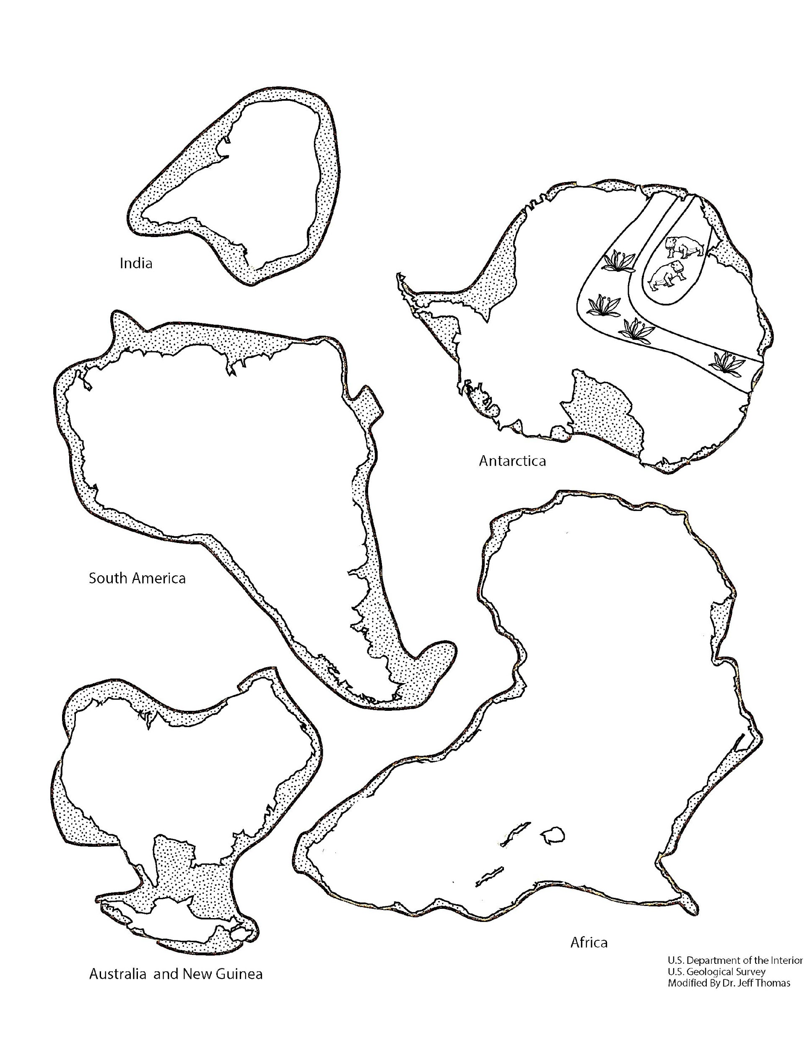
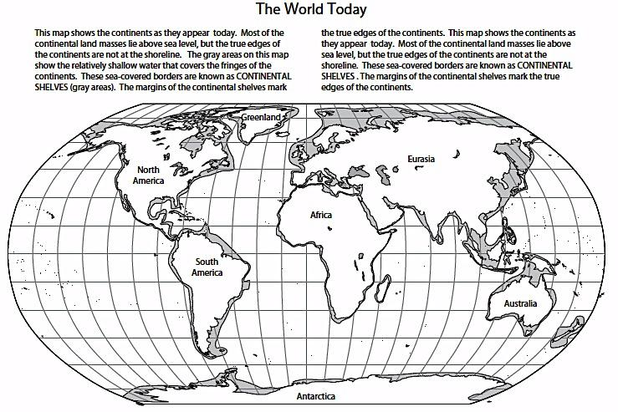
Figure 2: Present-day World Map

Evaluating and Revising Explanations.
- Share your proposed landmass with others. How do they compare?

- Obtain Wegener’s proposed landmass (see Appendix C). How does it compare to yours?

- Review Wegener’s probable explanation/hypothesis again. How might this new evidence (i.e. Wegener’s Landmass) support this explanation? Please justify.
NOTE: Consider where the single landmass might be located on the current world map below? Use the fossil evidence to support the claim.

Conclusions.
- Review your initial explanation/hypothesis from Investigation 1. How might the evidence from this investigation support, add to, or refute your initial explanation/hypothesis? Considering this new evidence, revise your explanation/ hypothesis in the unit summary table (see Appendix B).

Investigation 3: Earth’s Plates and Plate Boundaries

(Explore Activity #2)

Introduction.

To date, we have some evidence that Earth’s landmasses have moved based on fossil evidence. This was based on multiple lines of fossil evidence that we examined in Investigation 2. However, to further develop our plausible explanation/hypothesis about what prehistoric CT looked like (e.g. tropical climate) and if Connecticut in fact has moved over time, we need additional evidence to support this hypothesis. Thus, we will explore geologic data that scientists have been examining as additional lines of evidence to support our initial explanation/ hypothesis.

One scientific discovery, not so long ago, has been that Earth’s landmasses are divided into plates. A plate is a section of the upper part of the Earth (closest to the surface) that includes both continental crust and oceanic crust (see handout of Earth’s plates by your teacher). Today, each group of scientists such as seismologists, volcanologists, geographers, and geochronologists are studying these plates in order to try to understand if they are moving. They have yet to succeed to develop a good probable explanation, thus asking for your help.

The Task.

Your goal is to help these scientists to understand if certain geologic data (see below) can support the probable explanation that the Earth’s landmasses have moved. This evidence might also support that Connecticut has moved.
During this investigation, you will be assigned a scientific specialty (see table below). With your instructor, record what each scientist does and the kind of data they primarily analyze.
Table 3.1 Geoscience Specialties
Scientist | Studies… | Collects Data Such As…
A. Seismologist
B. Volcanologist
C. Geographer
D. Geochronologist

Part 1: Making Observations of Geologic Data—Identifying Patterns
The goal for the first part of this investigation is for you to analyze single-set geoscience data (e.g. earthquake epicenters and magnitude) along plate boundaries. You will use this data to identify patterns—three to five distinct patterns. NOTE: At this point, we will not explain WHY these patterns occur, just that they do.
Procedures.
- In your lab groups, you will be assigned two or three lithospheric plates (e.g. South America, Nazca) from the Plate Boundary map (separate handout given by your teacher). Record your assigned plates in Table 3.2. In addition, provide a brief description of where the plates are located on the map.
Table 3.2: Assigned Plate from the Plate Boundary Map
Assigned Plates | Description of the Location of the Plates

- Per lab group, obtain one copy of all four data maps that include: Seismology, Volcanology, Seafloor Age, Topography/Bathymetry
- Using Table 3.2, each person from your lab group will be assigned a specialty map. Decide among your group members which specialty you will be by circling it. Please note this will be your expert group for the next step of this investigation.
  - Next, with your data map, complete the OWL chart (Table 3.3) by recording at least three ideas for each: what you observe, what you are wondering about, and what you learned.
  - After you do so, each member must share their responses with the lab group and record them in the table below to complete the entire table.
Table 3.3: OWL Chart—Observe, Wonder, and Learned
Specialty Map | Observe | Wonder | Learned
Seismology

Volcanology

Seafloor Age

Topography/ Bathymetry

Part 2: Classifying Geoscience Data based on Observed Patterns
One way to start making meaning of the observed patterns is to classify them based on unique characteristics. For instance, humans are nearly identical to chimps. Yet, there are clear differences, which is why we are classified as different species. Thus, your task is to classify data patterns from your specialty map; please know there may be overlapping similarities, but there should be some characteristics in the patterns that are unique (like human and chimps).

Materials.
Plate Boundary Map (a transparency and a paper)
Scientific Specialty Data Maps (one type)
Transparency Colored Markers and Colored Pencils

Procedures.
- From your lab group (all four data sets), get into expert groups (e.g. seismology), which are based on the data you specialized in from your lab group in Part 1 of this investigation.
- In “expert” groups, classify your plate boundaries (just the boundary, not the entire plate) based on your assigned lithospheric plates. Using your data, create 3-5 classification groups. EVERYONE in the expert group must have the same classification scheme, regardless of your assigned plates.
IMPORTANT: Follow the following remaining steps first by placing the transparency of the plate boundary map on top of the data map to classify your data patterns. This is because you may change your classification scheme as you develop it and this will make it easier to do so. Once you finalize your scheme, then you can use the paper copy to record your final version.
HINTS: Below are some suggestions to analyze the data:
A) If you are studying the seismology or volcanology, think about distribution patterns.
B) If you are studying the topography, think elevations like high vs. low.
C) If you are doing age of rocks, think old vs. young rocks; and/or the age of the rocks.
- Record a title of your expertise on the top of the plate boundary map.
- Make a classification legend on your plate boundary map. The legend must include the following criteria like Table 3.4 below:
  - a classification group name
  - a classification group color
  - a description of the group--include both quantitative and qualitative data descriptions NOTE--the volcanoes data is the only one without quantitative data
- Color your plate boundary using your classification system. Color only the plate boundary, not the entire plate. Everyone in the group recheck classifications before you return to your lab group.
Table 3.4: Classification Legend
Name of Classification Group | Color Key | Description of Classification  (Criteria/Evidence from Map)

Part 3: Synthesizing Multiple Lines of Evidence
The objective for the previous part of this investigation was for you to analyze single-set geoscience data (e.g. earthquake epicenters and magnitude) along plate boundaries. Now, you will analyze patterns from multi-data sets in order to classify plate boundaries in a new and dynamic way.

Materials.
One Plate Boundary Map (paper & transparency)
Scientific Specialty Data Maps (four types) | Colored Pencils

Procedures.
- Get into lab groups (all four kinds of scientists). Share your map, data, classification scheme, and justification for it with each member.
- Create a NEW classification system that includes all four data sets into 3-5 categories. IMPORTANT: All four data sets must be represented in each classification group.
- Make a classification legend on your plate boundary map. The legend must include the following criteria like Table 3.5 below:
  - a classification group name
  - a classification group color
  - a description of the group--include both quantitative and qualitative data descriptions NOTE--the volcanoes data is the only one without quantitative data
- Color your plate boundary using your classification system. Color only the plate boundary, not the entire plate.
Table 3.5: Classification Legend
Name of Classification Group | Color Key | Description of Classification  (Criteria/Evidence from Map)

Part 4: Talk Moves—Evaluating Plate Boundaries and Classification System
During this part of this investigation, each lab group must present their assigned plate boundaries maps and justify your classification system to the class. To do this, each lab group displays their maps and the classification using a projector/document camera. In Table 3.6, the listeners will record what was presented and record questions for the presenting group. After each presentation, will using the “Talk Moves Protocol” to discuss the findings.

Table 3.6: Talk Moves
Lab Group/ Lithospheric Plate | Description of Presentation | Questions for the Presenters
After all the presentations, fully explain how your plate map and classification system compare to others?

Part 5: Conclusions
Review your explanation/hypothesis from the unit summary table (see Appendix B). How might the evidence from this investigation support, add to, or refute your explanation? Considering this new evidence, please revise your explanation/hypothesis in the unit summary table.

Investigation 4: Do Plates Move?

(Explain Activity #1)

Introduction.
Understanding lithospheric plates and plate boundaries provides clues to how Earth’s landmasses have moved over long periods of time. During the previous investigation, you developed a classification scheme for plate boundaries to help you begin to understand the the dynamic nature of the process by examining earthquake, volcanic, sea floor age, and topography/bathymetry data.

The Task.
Our goal for this investigation is to research sources about lithospheric plates and plate boundaries and compare to what we have learned so far. We will further clarify the different types of lithospheric plates, plate boundaries, and how they move.

Part 1: Comparing Plate Boundary Classification Systems
Recently, a group of scientists classified plate boundaries into three major categories—convergent, divergent, and transform fault boundaries, which is depicted in Figure 3. Review this map and answer the questions that follow.
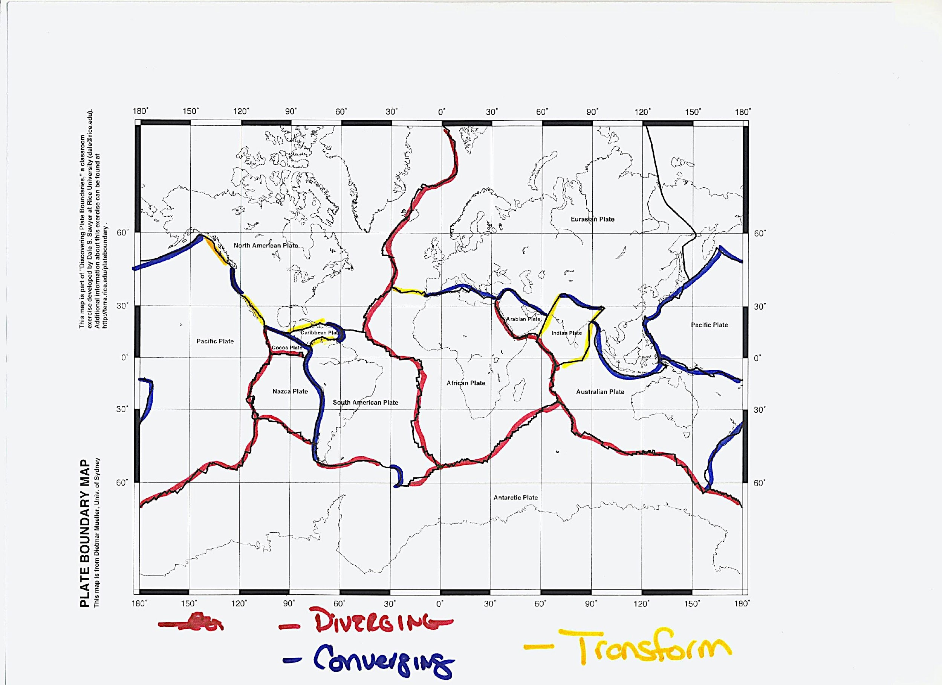
Figure 3: Scientists Version of a Plate Boundary Classification Map
- Fully describe what the plate boundary map is telling you.

- Next, take out your lab group’s plate boundary classification map. In lab groups, compare your classification system with the scientist’s version by completing Table 4.1.
Table 4.1: Comparing Plate Boundary Maps
Our Lab Group’s Plate Boundary Map | Scientist’s Plate Boundary Map | Similarities Between both Plate Boundary Maps

- Describe what you learned from this task.

Part 2: Understanding Plates, Plate Boundaries, and Plate Motions
- You will read an online chapter, Understanding Plate Motions, from an online book titled This Dynamic Earth. You will read about plates, divergent, convergent, and transform fault plate boundaries, and how they move. You will read this chapter using the paragraph shrinking strategy. This will require pairs to read and then identify key ideas and then summarize the paragraph or section in 10 words or less. To complete this task, follow the steps below.
Reading Link Web Address: http://pubs.usgs.gov/gip/dynamic/understanding.html
  - Step 1. In pairs, skim the reading heading and length of each reading section (e.g. divergent). Decide which paragraphs or sections you will read. NOTE: Each partner must alternate reading each paragraph or section.
  - Step 2. One partner reads aloud the first paragraph or section.
  - Step 3. At the end of each paragraph or section, the first reader identifies the key ideas and summarizes the section in 10 words or fewer. Each partner will record the key ideas and summary in Table 4.2 below.
  - Step 3. Next, the other partner will read the second paragraph or section and identify the key ideas and record a summary for the section in 10 words or fewer.
  - Step 4. For each paragraph or section, alternate between partners. Be sure to record all key ideas and summaries in Table 4.2.
Table 4.2: Understanding Plate Motions—Paragraph Shrinking
Plate Boundary | Key Ideas | Summary (>10 words)
Divergent

Convergent

Transform Fault

Part 3: Analyzing Geologic Data with Plate Boundaries
- You will receive a booklet of various plate boundaries (16 of them), all of which focus on the three main types of plate boundaries and the geologic data related to them (from the previous investigation). As a class, we will review one example for each of the major type of plate boundary while you record in Table 4.3 a description of how the geoscience data relates to plate motions and the resulting landforms.
Link to Data Maps: http://plateboundary.rice.edu/all.4map.pdf
Table 4.3: Analyzing Geologic Data with Plate Boundaries
Type of Plate Boundary |  | Name of Plate | Description of how geoscience data relates to plate motions and land formations
Divergent
Convergent | Ocean- Ocean
 | Ocean- Continent
 | Continent- Continent
Transform
- In the space below, record your answer to this question. How do the maps we just analyzed add to your understanding of your own plate boundary classification map? Include at least three ideas that have changed as a result of what you just learned from Table 4.3. Be sure to explain fully.

Part 4: Developing an Explanation of a Plate Boundary Model
- Below is a model (see Figure 5) of what scientists use to depict plate boundary and plate motions from the USGS (see https://pubs.usgs.gov/gip/dynamic/Vigil.html). Based on what you learned, develop a written explanation of this model in Table 4.4 to describe how plates move. Please use all terms shown in Figure 4 in your explanation.
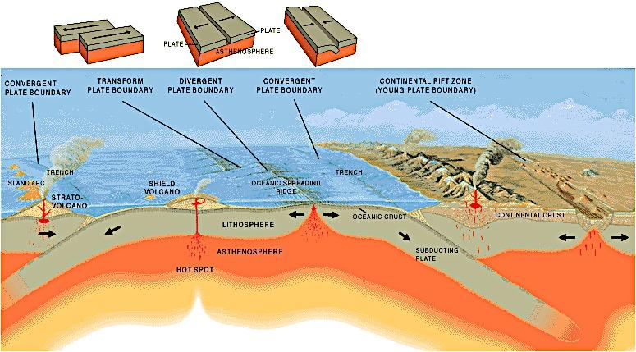
Figure 4: Cross Section of Main Types of Plate Boundaries

Table 4.4: My Explanation of the Plate Boundary Model
Muddiest Point.
- Based on your explanation from Table 4.4, what do you feel is the “muddiest point” of your explanation of the model (what is still confusing to you)?

Part 5: Conclusions
- Review your explanations/hypothesis from the unit summary table. How might the evidence from this investigation support, add to, or refute your explanations? Considering this new evidence, please revise your explanation/ hypothesis in the unit summary table.

Investigation 5: How Fast do Plate Move?

(Explain Activity #2)

Introduction: Pre-lab Activity.
- Examine Figure 5 below and explain the kind of information you think this image is telling you.

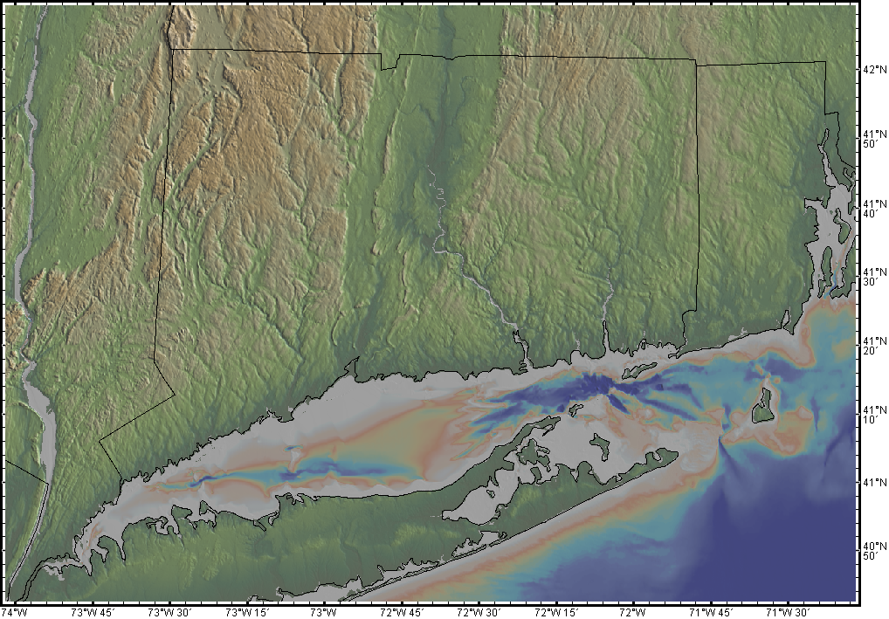
Figure 5: Topographic Map of Connecticut

- Examine Figure 6 below. Explain what you think this image is telling you to the greatest extent possible. In addition, record questions you may have about it.
Detailed Explanation | Questions

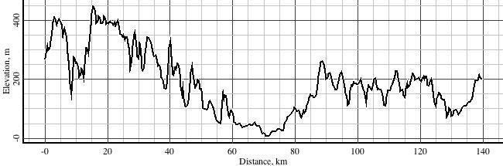
Figure 6: Topographic Profile of Connecticut
- What do you think might be the connection between Figure 6 and Figure 7? Explain fully.

NOTE: The above images are from GeoMapApp, an earth science application (and tool) developed by scientists from Earth Lamont Observatory at Columbia University. Please explore this tool by going to the homepage at http://www.geomapapp.org/index.htm as well as opening the app on your computer.

- Now that you have been introduced to GeoMapApp, “play around” with the tool in order to become familiar with it. Create a profile of your own from GeoMapApp and copy and paste in the space below.

The Task.
Previously, we read that Earth’s tectonic plates are moving. In this activity, our goal is to collect direct evidence (using GeoMapApp) to calculate plate motions along divergent boundaries along the ocean floor. Thus, our task will be to use seafloor age anomaly data to measure the distance in order to calculate seafloor spreading rates using the GeoMapApp tool (NOTE- scientists really use this application too). We will collect this data from the Mid Atlantic Ridge to help us better understand plate movements. To focus our investigation, we will respond to the following research question:

Part 1: Calculating Spreading Rates
What is the rate of movement along the Mid-Atlantic Ridge Divergent Plate Boundary?
Data Collection Procedures.
Since GeoMapApp is a technical tool with numerous capabilities, below are procedures to help you collect this data.
- Start GeoMapApp. Once you do, a map will display like the one below.
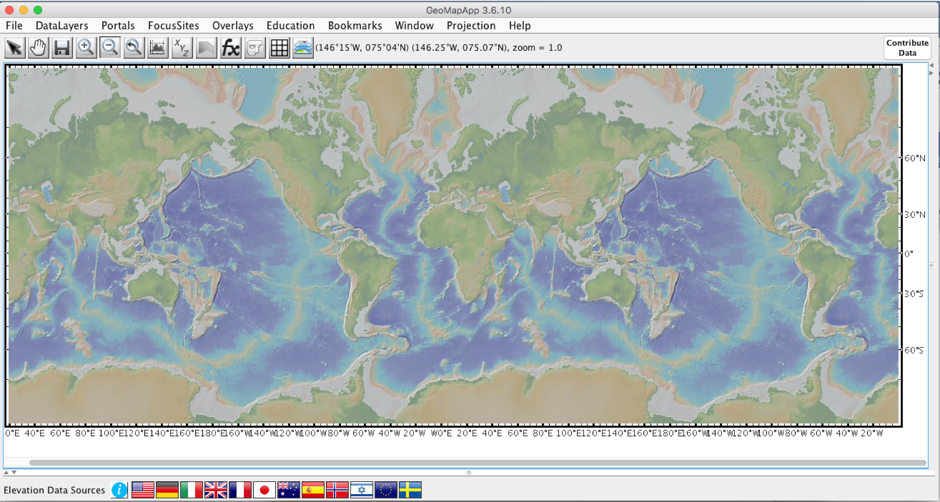
- Next, click on Portals and then click on Seafloor Magnetic Anomaly Identifier.
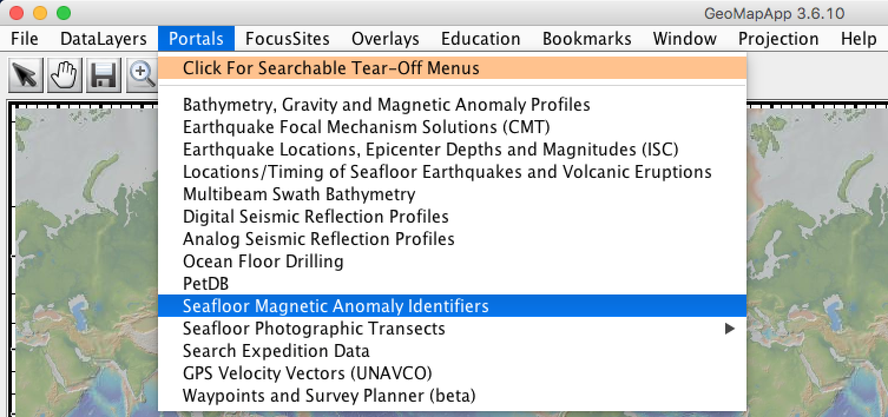
- When you complete #2, the map will overlay with the Seafloor Magnetic Anomaly Identifiers, which are lines of equal age. If you point and click one of the lines, the age of the ocean floor will appear in the bottom left-hand corner as indicated in the image below. Remove the overlay for now by clicking Identifier in the menu.
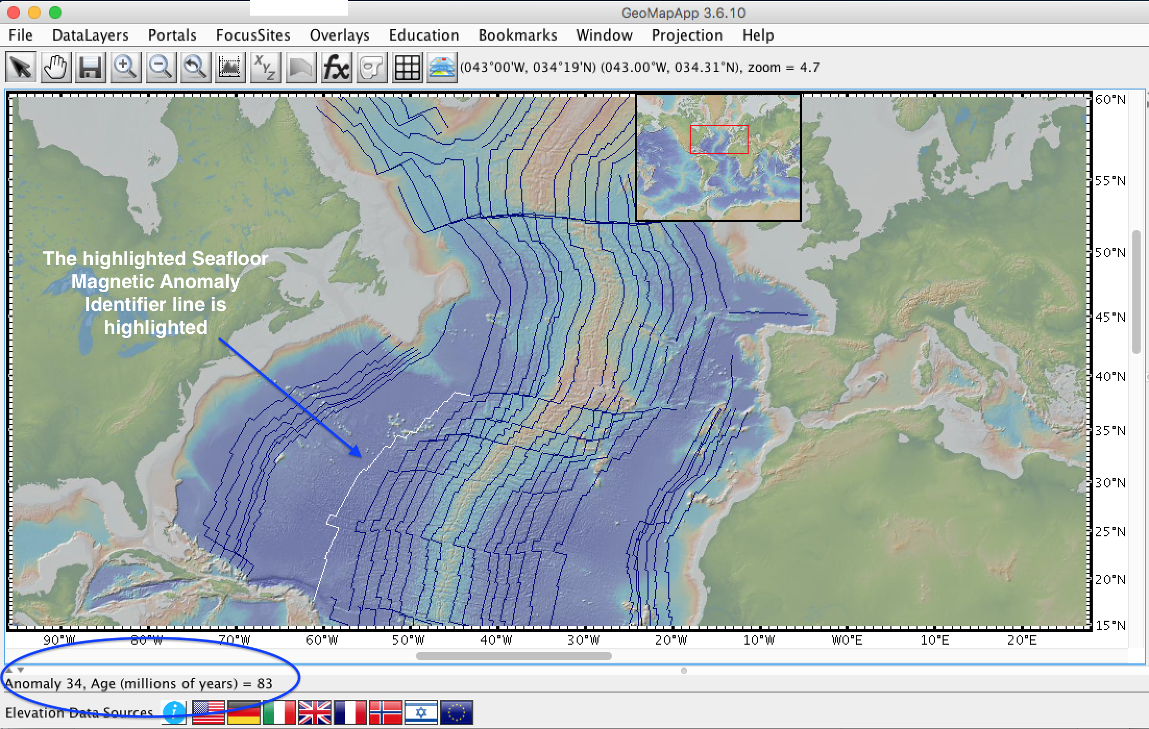
- Next, identify the Mid Atlantic Ridge, which is in the middle of the Atlantic Ocean. In the image below, the blue arrows point to the ridge, which is tan and orange colored.
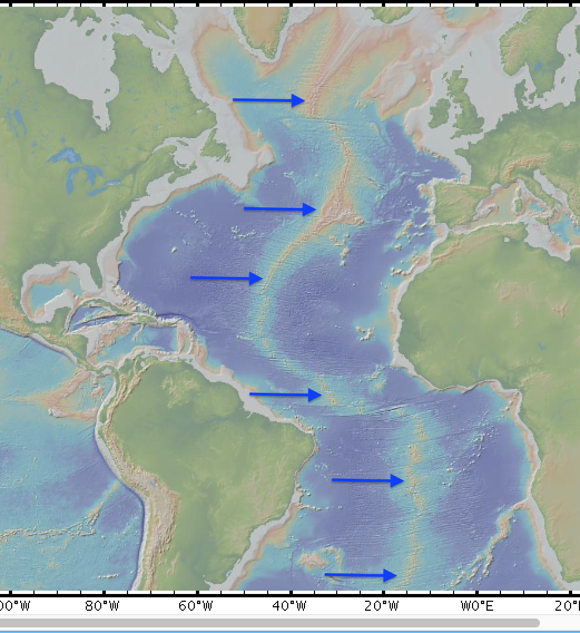
- In pairs, investigate either the northern part of the Mid-Atlantic Ridge (boundary between the North American and Eurasian plates) OR the southern part of the Mid-Atlantic Ridge (the boundary between the South American and African plates). Use the map in #4 to help.
  - Once you decide on the location, please zoom into your area. Do this by using the “zoom” tool, which is located on the top horizontal menu of GeoMapApp. As you zoom into your area, be sure to locate the CENTER of the spreading center, which has a bluer line in the middle, like what is depicted below.
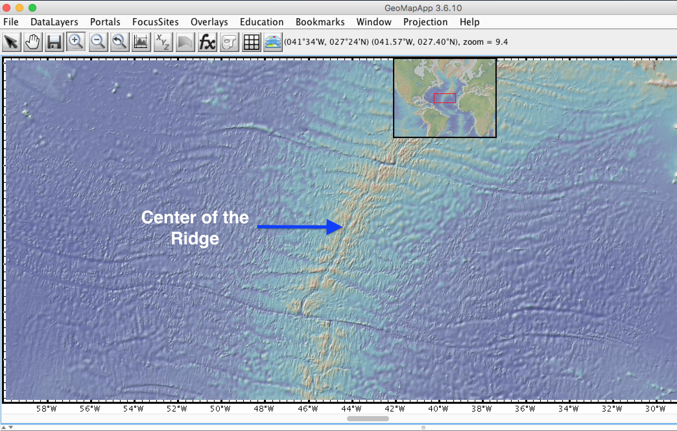
- Next, click on the “Portals” and then click on “Seafloor Magnetic Anomaly Identifier” again.
  - Click on the distance tool and then the first anomaly line (#5) to the left (or west) of the Ridge. Record the age of the oceanic crust at this location (see #2) in Table 5.1.
  - Then, drag the line PARALLEL to the CENTER of the ridge (see Step 5). The distance will appear in the upper right-hand corner, please record this in Table 5.1 too. For help, see image below.
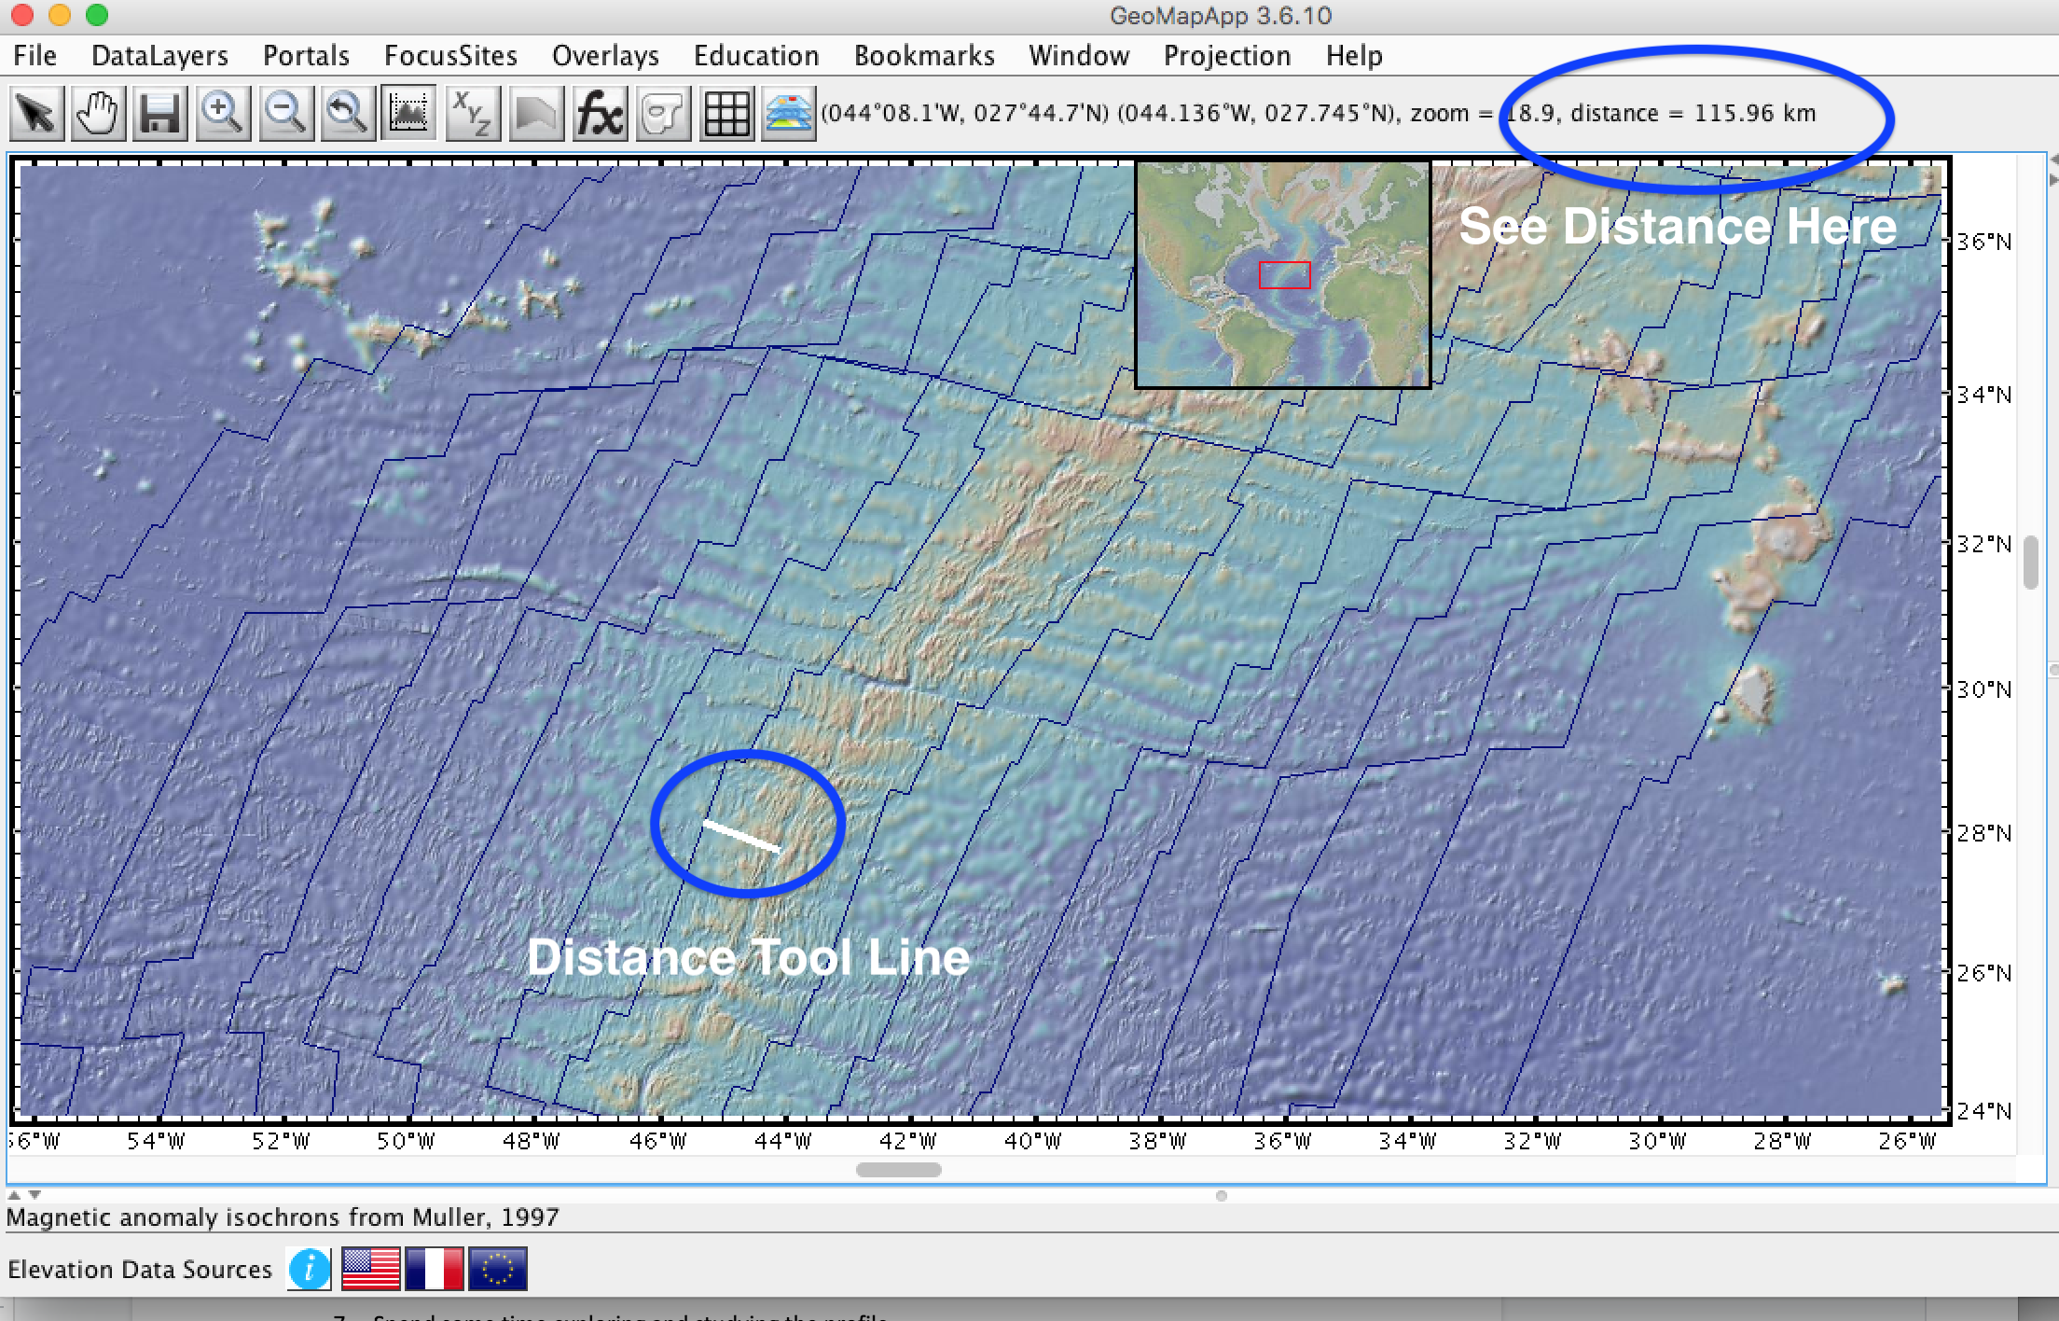
  - Next, complete the same steps, but for the exact opposite anomaly line to the right (or east) of the Ridge. Record the age and distance in Table 5.1.
  - Choose another anomaly line of your choice, but follow the same previous steps and record all age and distance data in Table 5.1.
- Rate is described as a change in distance over a period of time. The average rate of seafloor spreading is calculated by the following formula:
Rate of Spreading (from the spreading center) = Distance/Time
  - Currently, you recorded the distance in kilometers (km). Typically, spreading rates are calculated in cm/year. Thus, convert km to centimeters (cm). To do this, there are 100cm in 1m and there are 1000m in 1km. Thus, multiply your km value by 100,000 to convert this distance km to cm. Do this for all values in Table 5.1.
  - Next, calculate the spreading rate for both sides of the ridge using the formula above.
  - Finally, calculate the overall spreading rate for both the northern and southern portions of the Mid Atlantic Ridge.

Table 5.1: Calculating Spreading Rates Along the Mid-Atlantic Ridge
Location Along the Mid Atlantic Ridge |  | Left Side of the Spreading Center |  |  |  | Right Side of the Spreading Center |  |  |  | Average Spreading Rate  cm/yr.
 |  | Age  (Years) | Distance to Ridge Center (km) | Distance to Ridge Center (cm) | Spreading Rate cm/yr. | Age  (Years) | Distance to Ridge Center (km) | Distance to Ridge Center (cm) | Spreading Rate cm/yr.
Mid-Atlantic Ridge (northern) | Anomaly Line 5
 | Anomaly Line 13
Mid-Atlantic Ridge (southern) | Anomaly Line 5
 | Anomaly Line 6

- Discuss your Result from Table 5.1, including a complete response to this investigation research question: What is the rate of movement along the Mid-Atlantic Ridge Divergent Plate Boundary?

Part 2: Making Connections to the Scientific Literature
- Read the chapter, Developing a Theory from an online journal titled This Dynamic Earth. You will read this chapter with your partner using the Paragraph Shrinking Strategy.
Link: http://pubs.usgs.gov/gip/dynamic/developing.html
  - Step 1. In pairs, skim the headings and length of each paragraph and section. Decide which paragraphs or sections you will read. NOTE: Each partner must alternate reading each paragraph or section.
  - Step 2. One partner reads aloud the first paragraph or section.
  - Step 3. At the end of each paragraph or section, the first reader identifies the key ideas and summarizes the section in 10 words or fewer. Each partner will record the key ideas and summary in Table 5.2 below.
  - Step 3. Next, the other partner will read the second paragraph or section and identify the key ideas and summarizes the section in 10 words or fewer.
  - Step 4. For each paragraph or section, alternate between partners. Be sure to record all key ideas and summaries in Table 5.2.
Table 5.2: Understanding Plate Motions—Paragraph Shrinking
Title | Key Ideas | Summary (>10 words)
Introduction (no title)
Ocean floor mapping
Magnetic striping and polar reversals
Seafloor spreading and recycling of oceanic crust
Concentration of earthquakes
- After you have completed the reading strategy, record evidence from the article that supports and adds to your ideas from this investigation about the rates of motion at spreading centers.
Table 5.2: Comparing Our Ideas to Scientists’ Ideas
Supports my ideas about spreading centers | Adds to my ideas about spreading centers

Part 5: Conclusions
Review your explanation (tentative hypothesis) from the unit summary table. Complete the row for this investigation.

Investigation 6: What Moves Earth’s plates?
(Explain Activity #3)

Introduction.
Thus far, we learned how earth’s plates have moved, but we do not have an explanation for why the plates move. For this investigation, we will investigate the reasons why the plates move.

Part 1: Demonstration Lab
- First, we will complete a demo lab that relates to what might cause Earth’s plates to move. Before we do, we must introduce a few new science vocabulary words in Table 6.1 below. Please review them with your teacher.

Table 6.1: Important Vocabulary
Density: a measure of how compact or concentrated something is
For example, if you have two boxes, one large and one small, and they both weigh the same, the smaller box is denser, because more material must be packed into it.
Current: a continuous directed flow
Convection Currents: flow that transfers heat within a fluid
Fluid: a liquid or gas

Hypothesizing.
- Next, observe a lab demonstration wherein your teacher will fill a clear container with room temperature water. Paper continents will float on top of the water, representing Earth’s tectonic plates. Ice cubes and a beaker with hot water will be placed in the container. In the space below, write a hypothesis using an “if, then” statement to answer the questions we will be investigating today.
  - What will happen when hot water is placed in the container of water?
  - What will happen when the ice cubes are placed in the container of water?
  - What will happen to the paper continents when the ice cubes and hot water are placed in the container?

Observations.
- Draw and label your observations in the space below:

Results.
- In words, describe what you saw happen during the experiment.

Conclusions.
- What can you conclude about temperature and density?

Part 2: Plate Tectonics in a Nutshell
For this section, you will be given the most comprehensive plate tectonic model to date called “Plate Tectonics in a Nutshell,” from the United States Geological Survey (USGS). This model (see Figure 8) includes not only what is happening along earth’s plates, but depicts mechanisms for movement.
USGS Model link: http://volcanoes.usgs.gov/about/edu/dynamicplanet/platetectonics.pdf
Procedures.
- In the first column of Table 6.2 list the numbers associated with the USGS Plate Tectonic Model (see Figure 7). Record what is in this part of the model in the second column and what is happening in the third column. The USGS has a publication that might help; use the following link: http://pubs.usgs.gov/gip/dynamic/unanswered.html.
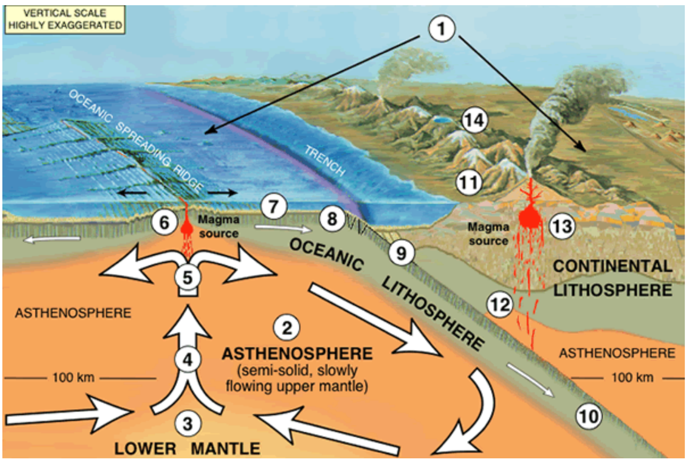
Figure 7: Plate Tectonics in a Nutshell (see USGS Dynamic Earth Teaching Companion)

- After you complete the second and third columns, record any questions you have in the fourth column. For the questions, you are not required to complete each row, but you should record at least three to five questions in total.
Table 6.2: What Drives Earth’s Plates?
 | What is this part of the model? | What is Happening? | Questions? | Clarification from Expert Explanation
1
2
3
4
5
6
7
8
9
10
11
12
13
14
Clarification from Expert Explanation.
- For the last column, Clarification from Expert Explanation, read the USGS article (see link below pages 7-9). This article gives you the full explanation of the plate tectonics model for each number. Compare this explanation to your own. Add any missing information or clarifications to the last column of your graphic organizer.
Link to USGS Explanation: http://volcanoes.usgs.gov/about/edu/dynamicplanet/nutshell.php

Part 3: Putting it all Together
- In Part 1 of this investigation, you saw a demonstration that showed how convection currents work. Apply this knowledge to what you learned from the reading from Part 2. Answer this question: What drives the motion of Earth’s tectonic plates? In other words, what inside the earth causes tectonic plates to move?
IMPORTANT: The response to the above question should be answered using the Claim, Evidence, Reasoning strategy.
Element | Response
Claims
Evidence
Reasoning

Part 4: Conclusions
Review your explanation (tentative hypothesis) from the unit summary table. Complete the row for this investigation.

Investigation 7: How did Connecticut Move?
(Elaborate Activity)

Introduction.
Scientists have recently developed an earth evolution computer model, based on significant geological evidence (e.g. dinosaur fossils), that depicts changes in the earth’s continents and oceans over the past 750 million years. This model can be useful for us to figure out how the climate of Connecticut changed as well as how the shape of the land changed.

Task.
Our goal main goal for this activity is to provide an explanation for how CT changed from a warm and tropical environment hundreds of millions of years ago when dinosaurs roamed our area to the temperate climate we have today. Moreover, we also learned that movements of earth’s crust also create various landforms (e.g. mountains, oceans).

Figure 2: Eubrontes Dinosaur Footprints in CT

To meet this goal, first we will use the “Interactive Globe of Ancient Earth” computer model (see link below) to describe how the continent and oceans have changed over the past 500 million years. Second, as a class, we will use the computer model to construct a plate tectonic model of how Connecticut formed when Pangea formed. Finally, in lab groups, you will use the computer model to develop your own plate tectonic model of how Connecticut changed during the break-up of Pangea from 200 million years ago (the age of the dinosaur prints from Dinosaur State Park, see Figure 1 above) to present.
Earth Evolution Computer Model: http://dinosaurpictures.org/ancient-earth#170

Before we get started, recall our initial unit phenomenon. Briefly describe it below.

Part 1: How have Earth’s continents and oceans changed?
      - As a class, go to the “Interactive Globe of Ancient Earth” at http://dinosaurpictures.org/ancient-earth#170
  - At the top center of the computer model, the globe will default to “What did Earth look like ‘170 million’ years ago.” Change it to 500 million years ago.
  - Click on “display options” in the upper left-hand corner. Click only the “show equator” and all other options off. Please note where the equator is located on the globe. This will be used as a frame of reference when analyzing positions of the continents and oceans.
  - In the upper right-hand corner, type in “Hartford, CT,” the largest city closest to Dinosaur State Park in Rocky Hill, CT.
  - As a class, describe this globe, specifically:
    - Areas of continents
    - Areas of oceans
    - The position of the equator
    - What the light-blue areas mean (i.e., continental shelves)
    - The outlines of present-day countries and continents

      - As a class, complete Table 7.1 below to describe changes in the continents and oceans, particularly how the position of Hartford CT changed over the past 500 million years. NOTE: An easy way to forward the time frame is to use the arrows ( or ) to step through time.
Table 7.1 Changing continents and oceans over 500 million of years
Time Frame  Millions of Years Ago (MYA) | Description of how Continents and oceans change position  (NOTE: use Hartford CT and the equator as reference points)
500-400
400-300
300-200
200-100
100-present day

Part 2: How did Pangea form?
      - As a class, go to “Interactive Globe of Ancient Earth” at http://dinosaurpictures.org/ancient-earth#170
  - At the top center of the model, the globe will default to “What did Earth look like ‘170 million’ years ago.” Change it to 400 million years ago.
  - Click on “display options” in the upper left-hand corner. Click only the “show equator” and all other options off. Please note where the equator is located on the globe. This will be used as a frame of reference when analyzing positions of the continents and oceans.
  - In the upper right-hand corner, type in “Hartford, CT,” the largest city closest to Dinosaur State Park in Rocky Hill, CT.
  - As a class, change the time frame to 400 million years ago. Describe the position of Connecticut relative to other land masses and oceans, the equator, and the outlines of present-day continents.
  - As a class, change the time frame to 240 million years ago. Describe the position of Connecticut relative to other land masses and oceans, the equator, and the outlines of present-day continents.
  - Toggle between 400 million and 240 million years ago using the arrows ( or ) on the keyboard to step through time. Describe the overall changes and explain how this change relates to what we know about Pangea.
  - Based on these changes along the surfaces, what kind of Plate boundary is Connecticut adjacent to during this time period? Make sure you all agree on this type of plate boundary.
      - As a class, develop a plate tectonic model, based on the kind of plate boundary we identified at 400 million and 240 million years ago. Please follow the procedures below.
        - Take a screen shot at 400 million and 240 million years ago. Draw a line/bar (see Figure 8 below) from Hartford CT to the present-day OUTLINE of the coast of Africa.
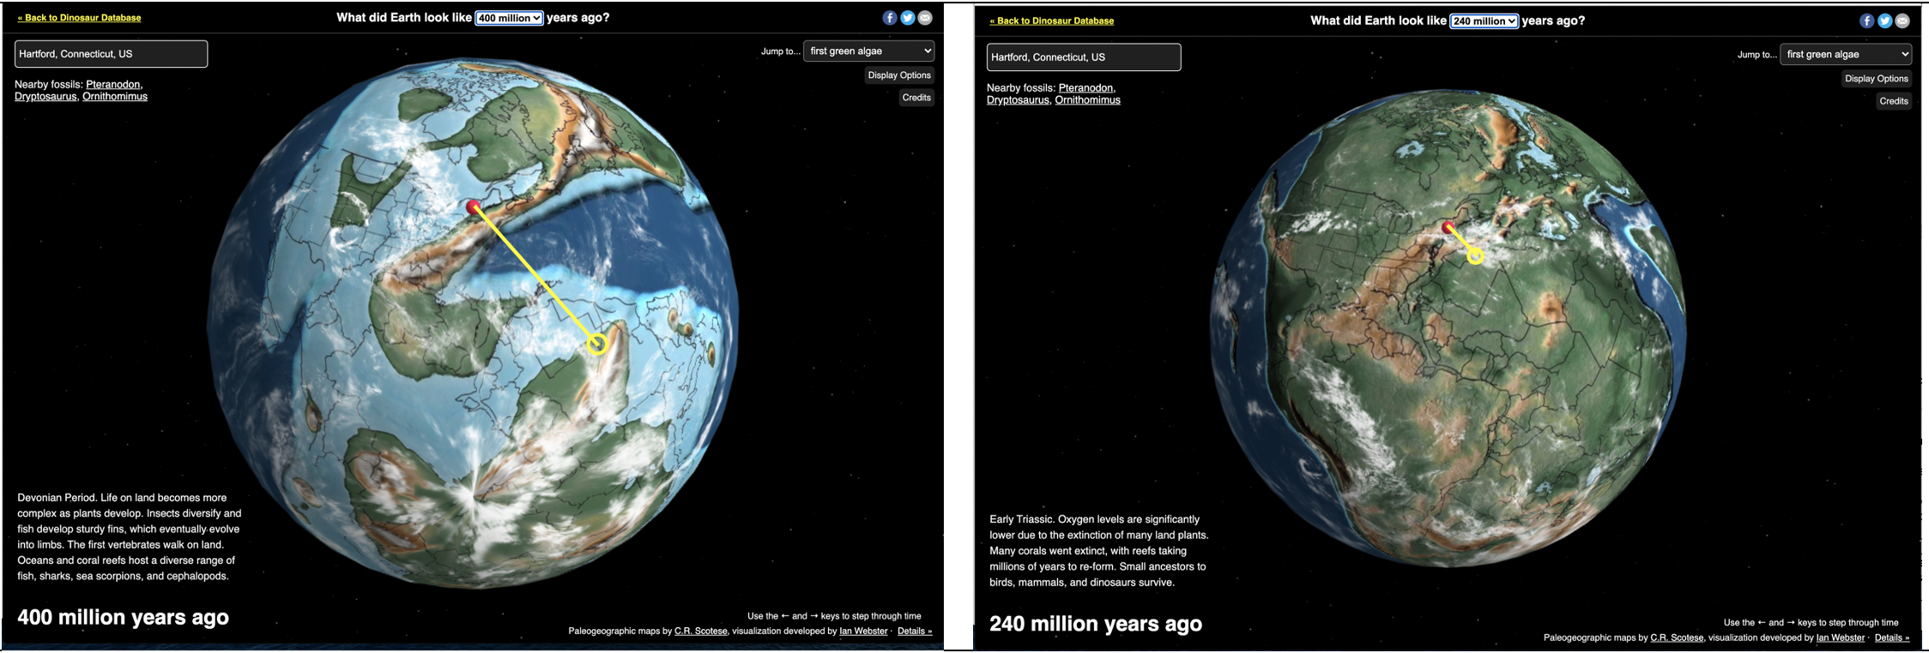
Figure 8: Ancient Earth 400 and 240 Million Years Ago
        - Create a plate tectonic model, like the generic model in Figure 7, of the areas of the map line or bar that goes from Hartford CT to Africa. Do this on poster paper with marker, etc. Please follow the criteria below to create your model. When you are done, take a picture and post it in Table 7.2 below.
    - Include ONLY the area near the line or bar (see Figure 8) such at Connecticut and what is present-day Africa. Make sure you identify where the fossils from Dinosaur State Park are located.
    - Show time passing. Do this at 400 million and 240 million years ago.
    - Draw all phenomena including elements you cannot see. This includes types of plate boundaries (e.g. convergent) and surface features (e.g. volcanoes, trenches).
    - Identify mechanisms that might be causing the movement of the continents.
IMPORTANT, you are drawing your plate tectonic model as it is specific to the location on the map that has the black “bar” drawn on it. “Copying” the model (e.g. Figure 7) is not exactly what is happening in each image underneath the line.

Table 7.2: Ancient Earth Model of CT During the Formation of Pangea

      - Next, Review the website below and I will demonstrate a “think aloud” strategy helping you to make sense of the text in order to build upon your formation of the Pangea model. To do this, your teachers will read part of an article to you that directly relates to this phenomenon. Record notes with your teacher in the space below.

Teacher note: The link to the article is below. It is suggested just to provide the reading related to changes to Connecticut at 400 and 240 million years ago. There is highly technical language, thus students will require supports. Summarizing the reading in student language will be required in the think aloud.

Long Island Resource Center (Geology) http://www.lisrc.uconn.edu/lisrc/geology.asp (click on Connecticut Geology)

Part 3: How did Connecticut change?
      - In LAB GROUPS, go to “Interactive Globe of Ancient Earth” at http://dinosaurpictures.org/ancient-earth#170
  - At the top center of the model, the globe will default to “What did Earth look like ‘170 million’ years ago.” Change it to 200 million years ago.
  - Click on “display options” in the upper left-hand corner. Click only “show equator” on and all other options off. Please note where the equator is located on the globe. This will be used as a frame of reference when analyzing positions of the continents and oceans.
  - In the upper right-hand corner, type in “Hartford, CT,” the largest city closest to Dinosaur State Park in Rocky Hill, CT.
  - In LAB GROUPS, at 200 million years ago, describe the position of Connecticut relative to other land masses, oceans, the equator, and the outlines of present-day continents.
  - In your LAB GROUP, change the time frame to 120 million years ago. Describe the position of Connecticut relative to other land masses and oceans, the equator, and the outlines of present-day continents.
  - In your LAB GROUP, change the time frame to Present Day. Describe the position of Connecticut relative to other land masses and oceans, the equator, and the outlines of present-day continents.
  - Toggle between 200 million years ago and Present Day using the arrows ( or ) on the keyboard to step through time. Describe an overall change and explain how this change relates to what we know about Pangea.
  - Based on these changes along the surfaces, what kind of Plate boundary is Connecticut adjacent to during this time period? Make sure you all agree on this type of plate boundary.

      - Finally, similar to Part 2, use the data you collected from how CT changed positions from 300 million years ago to present in the space below.
Part 4: Conclusions
Finally, complete the last row of the Summary Table.

Investigation 8: How Has CT Geologically Evolved Over Millions of Years?
(Evaluate Activity)

Now that you know what Connecticut’s climate and landscape may have been like 200 million years ago, we will use this model, plus what we learned throughout the entire unit (e.g., summary table) to explore what caused this drastic change. Thus, work with your group to create a science model that shows the process (mechanism) that caused this change.

To meet this goal, we will complete the following steps:
- Review the initial model
- Review the unit summary table
- Create a new, revised model
- Share your model
- Write a science explanation of your model

Your model and explanation will be graded based on the following criteria:
- Degree to which you make comparisons among pieces of evidence
- Degree of depth in your explanation
- Degree to which you recognize the logical nature of a scientific argument
Please review the different performance levels of these criteria at the end of this investigation.

Step 1: Review the Initial Model.
Review your initial model. What were the strengths of the initial model? What were the limitations of it? Record this evaluation in Table 8.1 below.
Table 8.1: Review of the Initial Plate Tectonic Model of CT
Strengths | Limitations

Step 2: Review the Summary Table.
- Next, review your summary table. Review all of your investigations again. What would you change? What do you want to add to it? When your modifications are complete, please print it out.
- Finally, highlight all the parts of the updated summary table that you will use for your new, revised model.

Step 3: Create Your New, Revised Model.
In groups, develop a plate tectonic model, based on the kind of plate boundary we identified at 200 million and 150 million years ago, and present-day (see Investigation 7). Go to “Interactive Globe of Ancient Earth” at http://dinosaurpictures.org/ancient-earth#170 then follow the proceudures below.
- At the top center of the model, the globe will default to “What did Earth look like ‘170 million’ years ago.” Change it to 200 million years ago.
- Click on “display options” in the upper left-hand corner. Click only “show equator” on and all other options off. Please note where the equator is located on the globe. This will be used as a frame of reference when analyzing positions of the continents and oceans.
- In the upper right-hand corner, type in “Hartford, CT,” the largest city closest to Dinosaur State Park in Rocky Hill, CT.
Below are screen shots from the Ancient Earth simulation at 200 million and 150 million years ago, and present-day. There is a yellow line/bar (see Figure 9) from Hartford CT to the present-day coast of Africa.

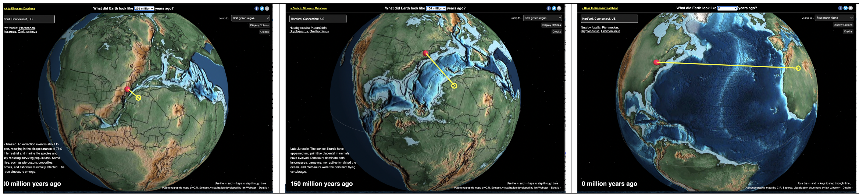
Figure 9: Ancient Earth 400 and 240 Million Years Ago

The directions for creating this new model are the same as your initial model. The revised model, however, should look much different than your initial model now that you know more about what creates poor air quality
Table 8.2: Gotta-have-it Checklist
- Title on top of model: What caused prehistoric Connecticut to change?
- The location of the phenomenon (CT)
- The landscape and climatic conditions, both observable and unobservable (e.g. temperature)
- Time passing—then and now (estimate timing if needed)
- The factors/mechanisms that caused the change in CT’s landscape
- Include labels (e.g., words & phrases) to identify parts of the model and arrows to identify relationships among the parts
- Names of group member in pencil on the back

Create a plate tectonic model, similar to the generic model in Figure 7, of the areas of the map line or bar that goes from Hartford CT to Africa. Do this on poster paper with marker, etc. Please follow the criteria to create your model. When you are done, take a picture and post it in Table 8.3 below.
- Include ONLY the area near the line or bar (see Figure 9) showing Connecticut and what is present-day Africa.
- Show time passing. Do this at each of the three time frames.
- Draw all phenomena including ones that you cannot see. This includes types of plate boundaries (e.g., convergent) and surface features (e.g. volcanoes, trenches).
- Identify mechanisms that might be causing the movement of the continents.
Steps to develop the create the plate tectonic model of CT:
- In groups, use poster paper to create a visual model that depicts what you think is happening, including all the factors and any or all relationships among them. Remember, the goal here is to depict and explain this phenomenon.
IMPORTANT, you are drawing plate tectonic models as it is specific to the location on the map that has the black “bar” drawn on it. “Copying” the model (e.g. Figure 7) is not exactly what is happening in each image underneath the line.
Step 4: Share Your Model.

Share your poster—post it around the room! Then, visit other groups' posters and provide feedback to each of them. You are limited to three types of feedback which include:
- Adding an idea—use ____GREEN__ __sticky notes. An example of this might be providing a NEW idea you believe will improve the model.
- Revising an idea—use _____BLUE______ sticky notes. An example of this might be suggesting a CURRENT idea on the model might not be complete.
- Posing a question—use ___YELLOW___ sticky notes. An example of this might be asking a question to clarify an idea about the model or provide more “food for thought” for the group who created the mode.
Second, review the comments on your poster and complete Table 8.3 below.

Table 8.3: Final Evaluation of the Air Pollution Model
Which ideas will you add to your model based on your feedback, if any | Which ideas will your revise to your model based on your feedback, if any | What questions that others posed would you address as part of your model?

Finally, number your entire poster in the order that you want to write your science explanation. Take a picture of the model and paste it in Table 8.4 below.
Table 8.4: Our Final Air Quality Model

Step 5: Write the Final Explanation.
For the last step, each individual will write their own final explanation, a 200- to 500-word explanation that responds to the unit research question:
What caused Connecticut’s climate and landscape to change so drastically from 200 million years ago?
The only resource that you can use for this task is the summary table. The criteria to include in your explanation are listed in the “Gotta Have it Checklist” below. The rubric then follows the checklist.
Table 8.5: Gotta Have it” Checklist
Content:
- Understands the purpose of writing a scientific explanation
  - Explains how Connecticut has changed in terms of topography and climate over time...
    - During the formation of Pangaea, including how CT was part of this formation
    - During the breakup of Pangaea, including how CT was part of this breakup
    - For the present-day plate boundary system
  - Explains how the science behind the plate tectonic model is associated with the geologic changes of CT.
Wow-me Points
- Connections CT dinosaurs, fauna, climate, weathering and erosion
Writing:
- Expresses ideas using own language as opposed to copying down what others say
  - Uses topic-specific vocabulary
- Begins writing with an opening general statement about the subject
- Develops explanation with concrete examples from the unit activities
- Concludes with a summary statement
- Uses good writing mechanics (i.e., grammar and punctuation)

Scientific Explanation Rubric
 | Criteria | 3 | 2 | 1
Science Content | EXPLANATION  Explains how Connecticut geologically evolved over the past 500 million years. Integrates how the science of plate tectonics influenced geological changes with Connecticut’s shape and topography as well as its climate. | Writes an accurate and complete explanation | Writes an accurate but incomplete or unclear explanation. | Writes a simple description of the events rather than an explanation, or makes an inaccurate explanation
 | EVIDENCE  Geological data supports the explanation. The data needs to be appropriate and sufficient to support the explanation:  Appropriate: data is from reliable, accurate, and relevant unit sources.  Sufficient: enough data are included to clearly support explanation. | Provides appropriate and sufficient evidence to fully support explanation. | Provides appropriate, but insufficient evidence to support explanation. | Provides inappropriate or no evidence to support explanation.
 | REASONING  A justification that connects the evidence to the explanation. It shows why the data counts as evidence by using appropriate and sufficient principles. | Provides reasoning that connects the evidence to the. Includes appropriate and sufficient scientific principles to explain why the evidence supports the explanation. | Provides reasoning that connects evidence to the explanation; may include some scientific principles or justification for why the evidence supports the explanation, but not sufficient. | Does not provide reasoning or uses some reasoning that does not connect the evidence to the explanation.
Writing | OVERALL WRITING QUALITY  The manner in which the written composition functions as a whole.  Appropriate scientific tone: precision of communication, objective and authoritative; third person point of view. | Writing uses clear, concise language with accurate scientific terms and vocabulary (at least five); appropriate scientific tone. | Writing uses clear and understandable language with some use of accurate  scientific terms and vocabulary (between one and four) or may not use appropriate scientific tone. | Writing is somewhat unclear; does not include specific scientific terminology or vocabulary and/or uses tone inappropriate to science.
 | PARAGRAPH and SENTENCE STRUCTURE  The way the writing is structured in sentences and paragraphs.  Appropriate paragraphs: several paragraphs are used; organized by key ideas with supportive details; sentences sequenced within paragraphs.  Well-constructed sentences: sentences convey compete ideas and follow correct conventions (capitalization, punctuation). | Structures writing with appropriate paragraphs and well-constructed sentences. | Paragraphs not purposefully constructed or contains poorly constructed sentences. | Writing is not developed in appropriate paragraphs or sentences.
 | WRITING MECHANICS  The final written product contains correct grammar, punctuation, and spelling. | Uses appropriate grammar, punctuation, and spelling, with no more than four errors. | Several errors (5-7) in grammar, punctuation, and spelling. | Numerous (more than 7) grammar, punctuation, and spelling errors that interfere with communication.
*adapted from McNeill & Krajcik, 2011

Appendix A: PT Unit Summary Table
Unit Summary Table: Why was Connecticut Tropical When Dinosaurs Roamed the Earth?
Unit Activities:  These are the investigations we did | Data Patterns & Observations:  Record the evidence of what happened | Why:  What factors/ mechanisms might cause these patterns? | Clues:  How does this help us figure out the unit phenomenon?
Investigation 2: Wegener’s Prehistoric Fossils
Investigation 3: Earth’s Plates and Plate Boundaries
Investigation 4: Do Plate move?

Investigation 5: How fast do plates move?

Investigation 6: What Moves Earth’s Plates?

Investigation 7: How did Connecticut Move?

Appendix B: Fossils of the Connecticut River Valley
Below is the article “Fossils of the Connecticut River Valley” goes with Investigation 1. In addition, you should have access to an electronic version of this article with the weblinks embedded within it so you can access some of the academic language vocabulary that may be difficult to read.

Fossils of the Connecticut River Valley—Naila Eisa and Lorenzo Bellard, Trinity College
NOTE: This reading is part of a larger academic article titled Geology, Formation and Fossils of the Connecticut Valley

The first fossils found in the Connecticut Valley were discovered almost two centuries ago (Colber, 1970) by Edward Hitchcock, president of Amherst College and State Geologist of Massachusetts. Within his lifetime, Hitchcock collected over 20,000 fossil footprints, most of which he believed belonged to large birds. However, we now know the footprints were made by bipedal dinosaurs. Of the thousands of fossils found in the Connecticut Valley, a majority dated back to the Triassic period, which took place about 205 million years ago.

Though the valley boasts a large collection of fossils, there are two kinds of fossils found to be the most abundant: fossil footprints and fossilized remains of fish (Fortey, 2002). The former is the most common type found in Connecticut. Fossil footprints, impressions in the sediment or molds made by animals of that time, allow scientists to deduce the whereabouts of a particular animal and their lifestyle. Footprints are also capable of revealing certain physical aspects about the animal itself. Height, possibly weight, and the way they walked (physical stature/build) are all things that can be determined through footprints. On the other hand, the fossilized remains of the plants and animals give us more concrete evidence about the age of the specimen as well as their immediate history. This would include whether the animal was running, in a group, by itself, standing, etc. Unfortunately, when studying the Connecticut Valley, scientists must rely primarily on the fossil footprints to make assumption about past life.

Plants
Many of the plant fossils found in Connecticut Valley give evidence to a green and tropical landscape, which existed during the Triassic period. The fossils found were those of coniferous trees, cycads, and ferns that are the typical vegetation for a tropical region. The fossils of the coniferous trees are similar to many species of trees found in the southern hemisphere such as the Araucaria, or Brazilian pine (Lull, 1953). However, no evidence was found that present day deciduous trees, grasses, and flowering plants existed. There were, on the other hand, larger versions of the present-day horsetails and club mosses. Within these jungles, were many lakes and ponds as well as mud banks that preserved many of the fish fossils and animal footprints found in the Connecticut Valley (Lull, 1953). Another way vegetation of the Triassic era is studied is through observation of well-preserved plant spores and pollen (plant gametes). The shale in which it is preserved can be dissolved in acid to study these tiny structures. About fifty different species of plants alone have been found in northeastern United States.

Fish
The discovery of thousands of fish fossils embedded in black shale sediments, located in regions once bottoms of the ancient lakes and ponds, provided evidence that the Connecticut Valley had held a large variety of fish. An abundance of fossils have been found near Durham, Connecticut. The fish bones found were flattened and covered by black fossilized scales. These bony fish, known as chondrostean, coelacanth, and holostean, are classified at the intermediate level in the evolutionary process of bony fish, as they are not as primitive as the ancient fish, and not as advanced as the modern day teleosts (Colber, 1970). The Chondrostean and Holostean fish have diamond-shaped scales, heavily boned skulls, and elongated bodies (Fortey, 2002). The Diplurus, a Triassic coelacanth fish, was found in Durham as well. An interesting fact is that the Latimeria, a present-day species of fish related to the ancient Diplurus, was found in abundance off the African coast several years ago. This discovery of the only “living fossil” known and it’s relation to some of the ancient air-breathing fishes (Colber, 1970) is an excellent clue to the study of the relationship and proximity between North America and Africa during the Triassic age.

Invertebrates
Plants and fish aren’t the only fossils found in the Connecticut Valley. Remains and tracks of insects were preserved as well. By studying these, scientists have determined that these tropical insects fluttered and crawled about the mud, along the banks of the lakes and ponds found in the jungles. One such insect fossil found was the Mormolucoides, the oldest insect larva found. In addition, fossil evidence shows that beetles, crickets, cockroaches, and dragonflies also existed and were abundant (Bell, 1985). Fossils of ancient clams have been studied as well. These fossilized remains are very similar in appearance to the clams that exist today. The similarities between the insects and clams of the Triassic period and those of today prove that these species of organisms were very successful in terms of evolution.

Reptiles and Dinosaurs
Fossil footprints of reptiles are copious and well-preserved in the Connecticut Valley, though the actual skeletal remains have been lost. This is primarily because the brownstone red-bed within Connecticut Valley causes rapid decomposition of the bones. One of the most widely studied reptiles of the valley is dinosaurs, namely the Anchisaurus, the Ammosaurus, the Yaleosaurus, and the Coelophysis (Little, 1986). The Anchisaurus, an ancestor of the giant sauropods of the Jurassic Period, is known to be a small dinosaur merely 6 to 8 feet tall. They walked in an erect position on their hind legs counterbalanced by their tails. Their front legs were small and used primarily to aid feeding. The Yaleosaurus shares similar characteristics to the Anchisaurus, though it is slightly bigger and possesses other differentiating physical characteristics. The partial remains of another dinosaur were found in 1884 near Manchester, Connecticut. This new species, named the Ammosaurus, is similar to the Anchisaurus and the Yaleosaurus. The Coelophysis is characterized by its lightly built and bird-like skeleton made of fragile and hollow bones. It is similar to the previous dinosaurs described, except smaller, thinner, with bird-like feet, and elongated limbs. These and other descriptions are derived from what little skeletal remains are found in the valley. Based on the location of the remains, we now know these dinosaurs roamed the low mud flats in the base of the valley. Although these four dinosaurs have been identified, there are many more that have yet to be recognized, as there have been few clues available to describe the physical and behavioral characteristics of these reptiles.

Conclusion
Paleontologists who study fossil remains and footprints in the Connecticut River Valley have ascertained information that has helped increase understanding of the biodiversity and geological events of the past.

References

Bell, M., The Face of Connecticut, State Geological and Natural History Survey of Connecticut, Hartford, 1985, p.8.2.

Colber, E.H., Fossils of the Connecticut Valley, A division of the Department of the Agriculture and Natural Resources, Hartford, 1970. p 9-18.

Rodgers, E., Department of Environmental Protection (DEP), Bedrock Geologic Map of Connecticut, State Geological and Natural History Survey, Hartford, 1990.

Fortey, R., Fossils: The Key to the Past, Smithsonian Institution Press, Washington, 2002.
Little, R., Dinosaurs, Dunes, and Drifting Continents: The Geology of the Connecticut Valley, 3, Earth View LLC, East Hampton, 2003.

Lull, R.S., Triassic Life of the Connecticut Valley, Printed for the State Geological and Natural History Survey, Hartford, 1953.p.23-24.

Rasom, J.E., Fossils in America. Harper and Row Publishers, New York, 1964.
Selden, P., Nudds, J., Evolution of Fossil Ecosystems, University of Chicago Press, Chicago, 2004.

Appendix C: Answer Key for Investigation 2
